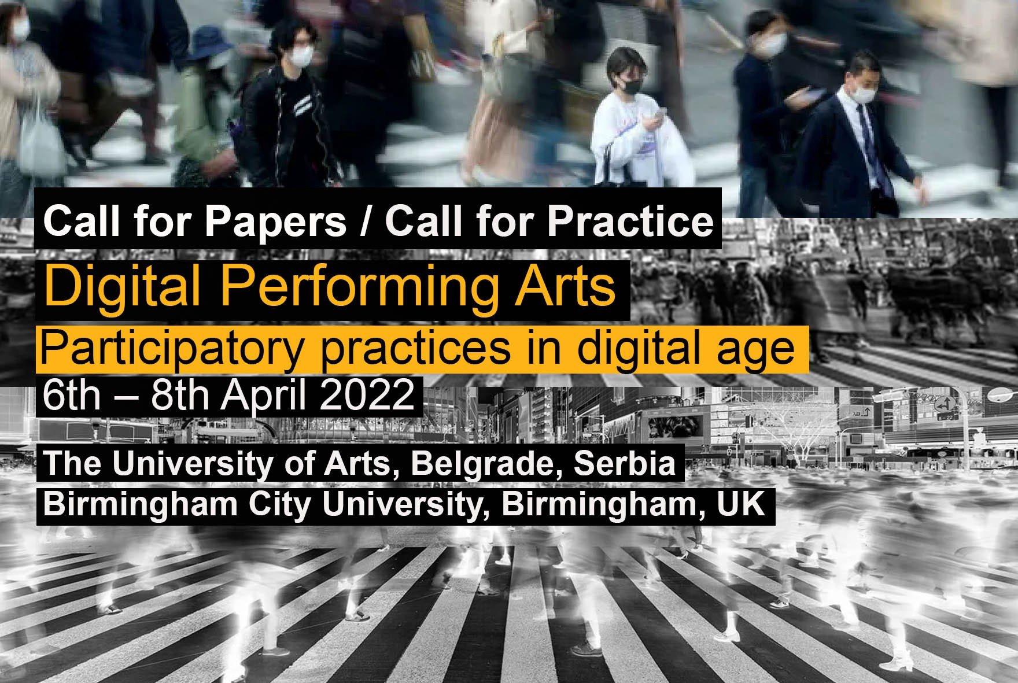

Hybrid International Conference (live and online) hosted by the University of Arts, Belgrade, in collaboration with Centre for Interdisciplinary Performative Arts (CIPA), Birmingham City University, U.K.

Conference Curators: Prof. Ivan Pravdic and Prof. Aleksandar Dundjerovic

The challenges of recent years have brought about significant changes to performing arts practice, education, and research. The particularly creative industry was affected by the C19 pandemic, with theatre and other public venues internationally being closed for most of 2020-21. The shifts in collective consciousness regarding the environmental, ethical, and cultural change, inclusivity decolonisation, diversity, and technological innovation have grown new ways of thinking, making performance and shifting to online production. The conference aims to examine the developments and investigate digital performing arts in the present moment working collectively and collaboratively. Scholars and practitioners across the board of interdisciplinary performing arts are invited to contribute with their submissions that will challenge and provoke the debate in connection to one or more suggested topics/themes:

* Decolonizing digital performance
* Disruption and response to Pandemic in education and creative digital arts
* Post-covid Digital Performing Arts ( incorporating live and digital)
* Political Activism in Digital Media
* Digital media as political propaganda
* New methodologies of Digital communication and Live Art
* Video Choreography
* Embodiment of physical and virtual bodies
* Practice Research in Interdisciplinary Performing Arts Education
* Performing the Digital Art (online platforms)
* Digitalising Live Performance (filmed theatre)
* Virtual Reality and the Real in Theatre
* The theatricality of Digital Media
* Adapting Dramatic Arts in Digital Performance
* Intermediality, Transmedia and Multimedia
* Crossing of Analogue and Digital
* Digital Theatre in Global Political and Socio-Cultural Contexts
* Democratisation through digital performance
* Heritage and memory in social media as performance
* Representation of History and Identity in digital media
* Ethics and diversity in digital performing arts

Submissions Contributors can choose from the submission formats:

Full Paper: 20-minute conference presentation (250 words abstract)

Practice project: 10-minute conference presentation of examples of digital performing arts practice-based work (1min edited video teaser)

**For all submissions, please provide:**

• Title

• Abstract (maximum 250 words)

• Keywords (5)

• Theme(s)

• Format – Full Paper, Practice project or Exhibit

• Author(s) and affiliation(s), option to include ORCID ID

• Biography for each author (maximum 150 words each)

**The Deadline for Submission is the 14th of March 2022, 1200 GMT.**

We are pleased to inform you that selected articles and practice projects/exhibitions from the conference will be submitted for publication to the University of Arts Press online (open access) and in paper form.

For the submission and all-conference information, follow the link:

<http://www.arts.bg.ac.rs/dpa-conference>

or by sending it to email:

[art.conference@arts.bg.ac.rs](mailto:art.conference@arts.bg.ac.rs)

Further information can be obtained on FB page and YouTube during the conference.

