TITLE

Name SURNAME
Name SURNAME
Name SURNAME

Abstract: This is instruction for the preparation of the camera-ready papers for the 10th international conference on Research and Development of Mechanical Elements and Systems – IRMES 2022, which will take place in Belgrade, Serbia, on 26. May 2022. These pages are an example of the layout and style, which we wish you to adopt during the preparation of the paper. Only papers prepared according to these instructions will be published. The abstract should summarize the paper in max 200 words. The Abstract and Keywords format: one-column, Times New Roman font, 10 pt, italic, single spacing, justified (aligned left and right), 0 pt before and after paragraph, 10 mm indentation left and right. Between Abstract and Keywords leave one blank line (10 pt). After Keywords leave two blank lines
(10 pt).

Keywords: up to 5( five) words; separated by semicolons

- INTRODUCTION

The text should be written in English. Paper has to be written on an even number of pages:
- max 14 pages for plenary and invited lectures and
- 6 or 8 pages for regular contribution papers which will be presented in poster form.
Page size: A4 (210 x 297 mm). Margins: mirror, 20 mm top and bottom, 25 mm inside, 15 mm outside. Layout: header 20 mm, footer 15 mm.
Title: one-column, Times New Roman, 12 pt, uppercase, bold, center, single spacing, 0 pt both before and after paragraph, 10 mm indentation both left and right.
Authors’ names: one-column, Times New Roman, 10 pt, Sentence case for Name and Uppercase for Surname, bold, center text, single spacing, 10 mm indentation left and right.
Before the title leave two blank lines (10 pt).
Between title and authors’ names, as well as between authors’ names and abstract leave two blank names
(10 pt).

- FORMAT

Body text: two-column (82.5 mm width of each and 5 mm between columns); Times New Roman font, 10pt, single spacing, justified (aligned left and right), 0 pt before and after paragraph.
The paper should be prepared according to the general instructions explained in Table 1.

Table 1. General editing instructions
No | Item | Explanation
 | Paper size | A4 format (210 x 297 mm). Only this paper size will be accepted.
 | Length | Regular papers should be 6 or 8 pages long; plenary and invited lectures could be on max 14 pages
 | Margins | Mirror margins, 20 mm at the top and the bottom, 25 mm as inside and 15 mm as outside margin
 | Layout | Header 20 mm, Footer 15 mm; different first page
 | Font | Times New Roman
 | Paragraph | Single spacing; 0 pt before and after paragraph

  - Section headings

Count the number of headings. Use max. two levels in your heading structure. Sections Acknowledgment, References and Correspondence are excluded from the heading count.
Section heading format: Times New Roman, 11 pt, uppercase, bold, align text left, single spacing, 0 pt both before and after paragraph, hanging 5 mm.
Subsection heading format: Times New Roman, 11 pt, sentence case, bold, align text left, single spacing, 0 pt both before and after paragraph, hanging 7.5 mm.
Section headings, subsection headings and body text should be separated by one blank line (10 pt).

  - References and authors information

Follow the instructions for each type of reference.
At the very end of the paper, in section Correspondence: author’s first name (10 pt, sentence case), last name
(10 pt, uppercase), title and scientific degree, name of the institution, address for correspondence and e-mail address. Please insert (“in line with text”) pictures of the author and coauthors (resolution at least 300 dpi). Resize pictures if needed (20 x 25 mm)

- TABLES AND FIGURES

  - Tables

Tables should be presented in the form shown in Table 1. The title of the table should be numbered and written above the table (Times New Roman, 10 pt, italic). Between text and table title, as well as between table and body text leave one blank line (10 pt). If a table is too wide to fit into one column (82.5 mm), you can put it in one page width column (170 mm), adding a new edit section („Section Break Continuous“). If a table is too long to fit into one page, the table number and headings should be repeated on the next page before the table is continued. Alternatively, the table can be spread over two consecutive pages turned 90° without repeating the headings.

  - Figures

The title of the figure should be numbered and written below the figure (10 pt, centered, italic). Before and after figure title, as well as between figure and body text leave one blank line (10 pt). All notations and lettering should be no less than 2 mm high. The use of heavy black, bold lettering should be avoided as they will look unpleasantly dark when printed. Pictures (resolution at least 300 dpi) should be inserted in the paper “in line with text”.

Fig.1. Good quality figure with clear lettering

Fig.2. Bad quality, distorted figure with too small letters

- EQUATIONS

Equations should be aligned left. Before and after the equation leave one blank line (10 pt).

$S(t)={λd}^{3}−\sum_{i=1}^{f}{s_{i}}$ (1)

If they are numbered make sure that they are numbered consequently. Put the numbers in parentheses and use the right tab position (82.5 mm) in the line of the equation.

- CONCLUSION

Please, remember the ‘fine-tuning’: do not end the page with a heading; do not start a page with an incomplete line; do not underline any part of the text. Please, try to align columns by horizontal at the top and bottom of each page.
The paper should be sent as an MS Word document by
e-mail irmes2022@mas.bg.ac.rs. The deadline for paper submission is 05. May 2022!

ACKNOWLEDGMENT

This research was supported...

REFERENCES

- Spotts, J., Blitzer, W., Gingrich, T.: Book Title in Italic, Publisher, Place of Publication, ISBN, 2008
- Cohen, B., Milbank, A., Romney, J.: Title of conference paper, Proceedings of xxx xxx, conference data in italic, date, location, pp. 11-19, ISBN, 2009
- Bachmann, A.: Paper title. Journal name in Italic, Vol., No., pp. 11-19, ISSN, 2021
- Harbaugh, K., McClain, A.: Paper title, In: Name of Book in Italics, Name(s) of Editor(s), pp.157-164, Publisher, Place of publication, ISBN, 2018
- http://www.nastit.hu - The National Statistics Institute, Statistics Year Book, Accessed on: 2010-05-18
- ISO number of standard (incl. year), Standard Title

CORRESPONDENCE

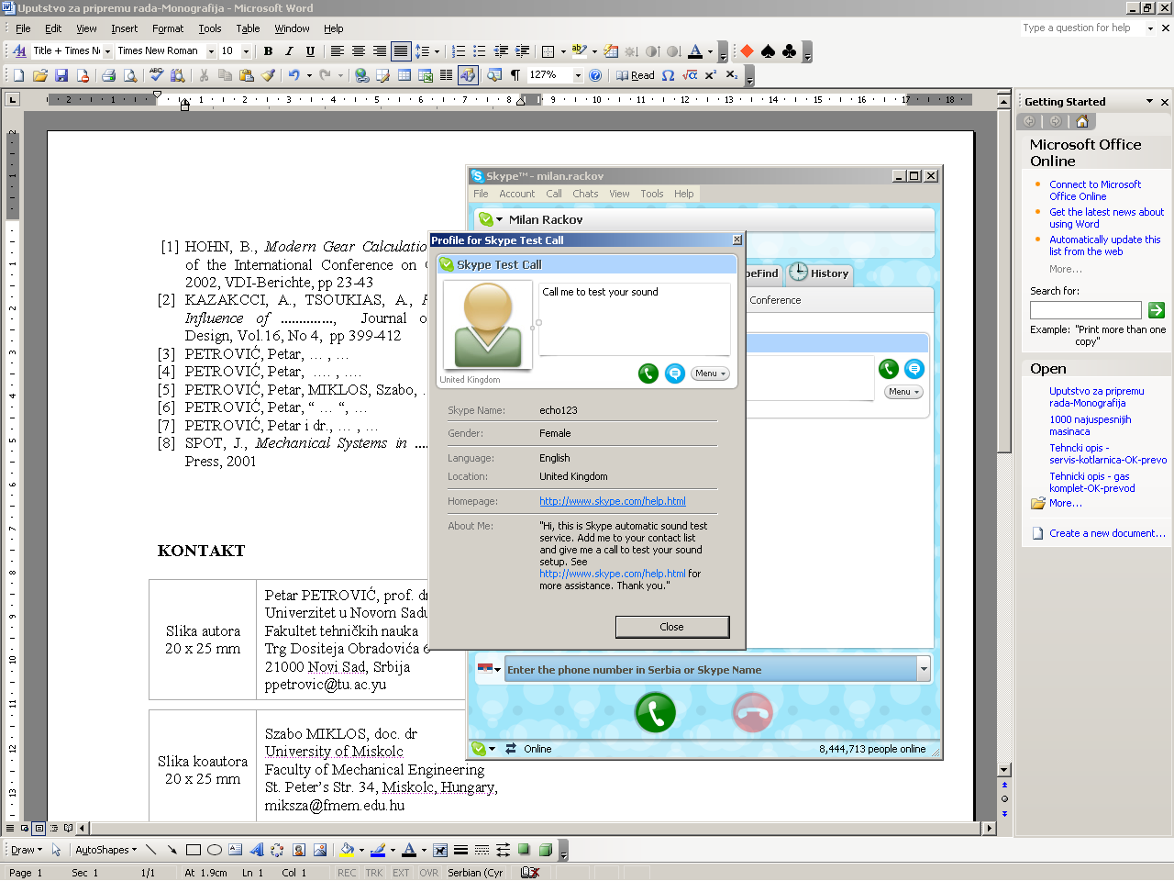 | Petar PEROVIC, Prof. D.Sc. Eng.  University of Belgrade  Faculty of Mechanical Engineering  Kraljice Marije 16  11120 Belgrade, Serbia  pperovic@mas.bg.ac.rs
Coauthor  photo  20 x 25 mm | Name SURNAME, Title, Acad.degree  Affiliation  Address  e-mail
Coauthor  photo  20 x 25 mm | Name SURNAME, Title, Acad.degree  Affiliation  Address  e-mail

